# Shokoban(1)

Game Complete

1. Version 1

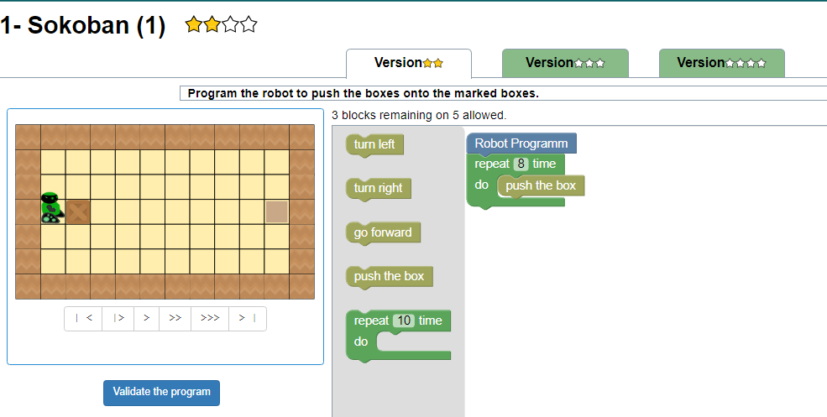

1. Version 2

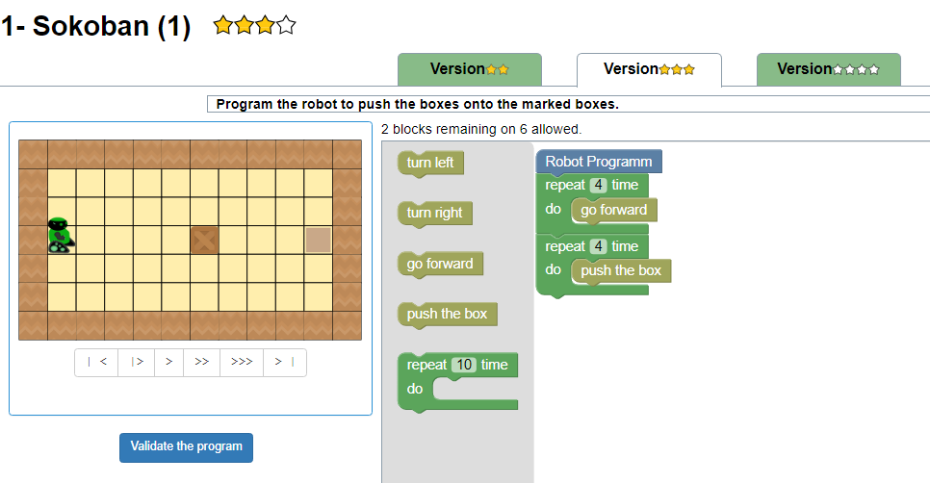

1. Version 3

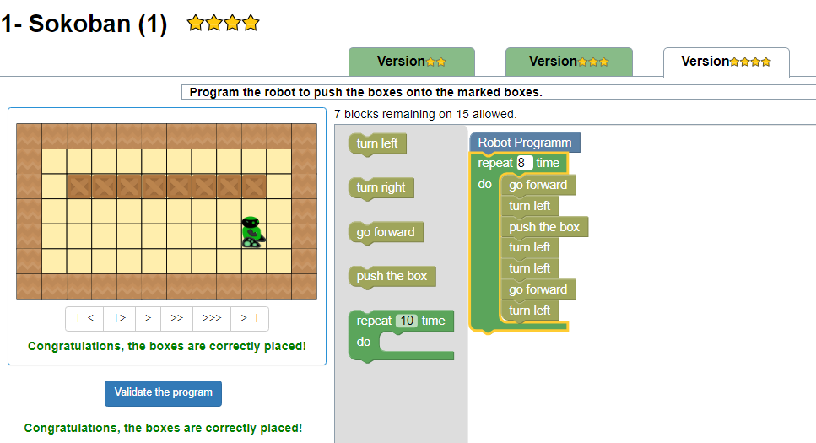

# How to use variable

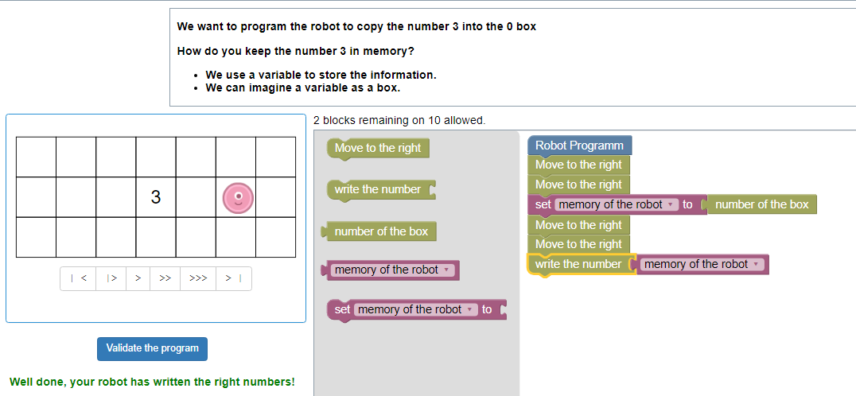

# Paint using the number(1)

1. 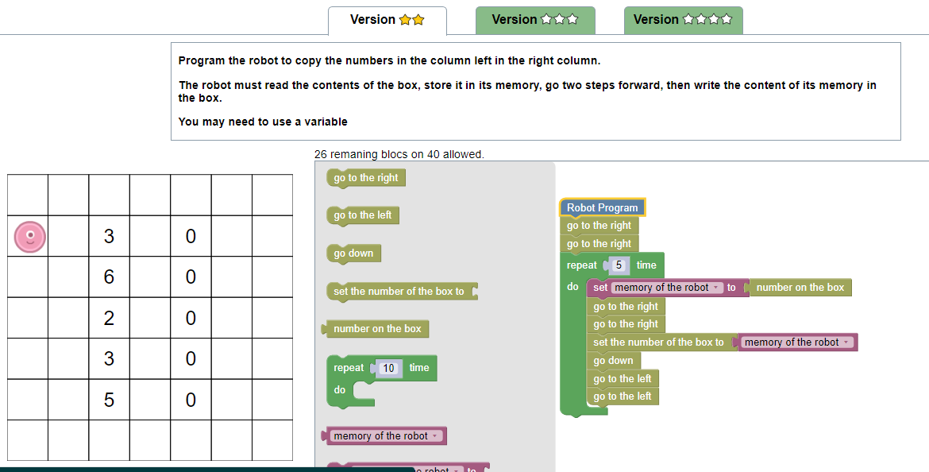Version 1
2. Version 2

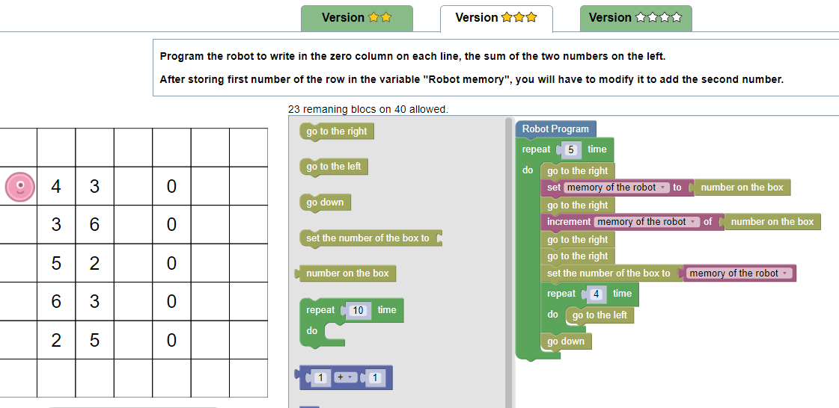

1. Version 3

# Paint using the number(2)

1. Version 1
2. Version 2
3. Version 3

# Paint using the number(3)

1. Version 1
2. Version 2
3. Version 3

# Shokoban(2)

1. Version 1
2. Version 2
3. Version 3

# Compute the sum

# Paint the dots(easy)

1. Version 1
2. Version 2
3. Version 3